**5. Debugging React apps.**

1) Whenever there is a syntax error, we can clearly see it on the browser as well as on the terminal.

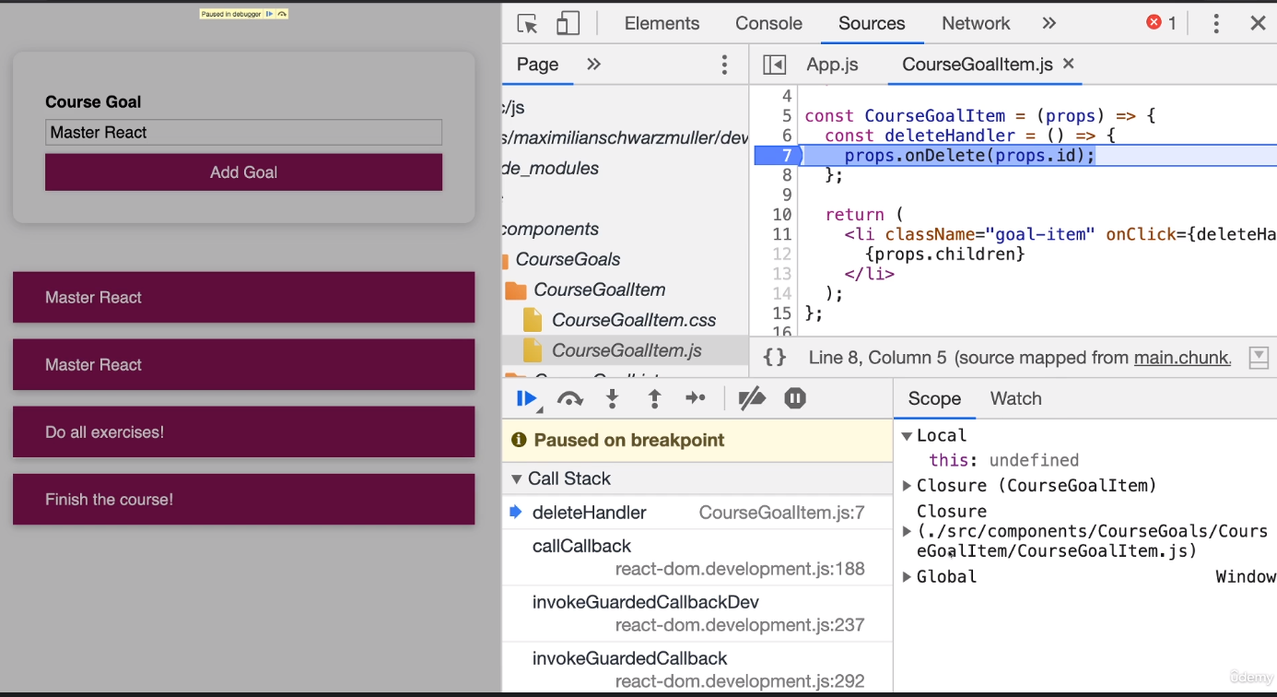

Debugger/breakpoints points can be added with react.

React Dev tools can be downloaded as an extension to the browser. Under components tab we can see the actual react component structure .

Here we can see all the details of the components along with their properties.

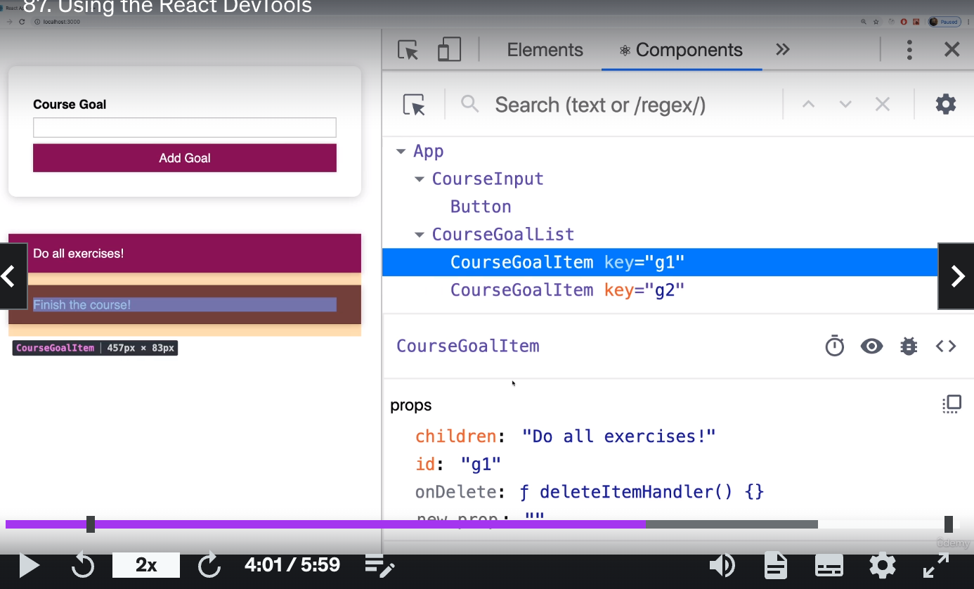

We can also see the state of the components.